Ajilon Consulting

EAGLS Web Application High Level Architecture

Last Updated: May 24, 2003

Prepared By:
NA


Ajilon Consulting
WaterPark Place
10 Bay Street, 7th Floor
Toronto, ON
M5J 2R8
www.ajilonconsulting.ca

Revisions Table

Date | Version | Description | Authors
May 24th, 2003 | 1.0 | Initial Version | NA

Review Log is maintained to show history of change in this document.

Table of Contents

1 Overview 5
2 Architecture Design Considerations 6
2.1 Extensibility 6
2.2 Security 6
2.3 Portability 6
2.4 Scalability 6
2.5 Modularity 6
2.6 Code Reuse 6
2.7 Reliability 6
2.8 Maintainability 7
2.9 Minimize network traffic 7
2.10 Performance 7
3 System Architecture Model 8
3.1 Logical View 8
3.2 Implementation View 9
3.2.1 Architecture Tiers 9
3.2.2 Application Client Tier Model 10
3.2.3 Presentation Tier Model 11
3.2.4 Business Tier Model 15
3.2.5 Data Persistence and EIS Tier Model 18
3.2.6 Components 18
3.2.7 Exception Handling 19
3.3 Deployment View 19
3.3.1 Deployment Diagram 19
3.4 Software Architecture 20
3.4.1 Essence of the Service Architecture 20
3.4.2 Service Diagram 20
3.4.3 Service Description 21
3.4.4 Other Security Services 22
3.5 Architecture Patterns 23
3.5.1 Singleton 23
3.5.2 Data Access Objects 23
3.5.3 Model-View-Controller 23
3.6 Software Design 24
3.6.1 High Level Package Hierarchy 24
3.6.2 Major Components 25
4 Security Design 31
4.1.1 Authentication 31
4.1.2 Authorization 31
5 EAGLS External Interfaces 33
6 Summary 35
7 Reference 36

Overview

This design document is an outline of the software/hardware architecture for the EAGLS (Electronic Account Government Ledger System) Web Application. It defines a framework of the software/hardware and addresses the technologies used to implement the system. It concentrates on evaluating the architecture for performance, reliability, availability, security, modifiability, portability, functionality, variability, usability, reliability, maintainability and conceptual integrity.

This document is designed for stakeholders to understand the architectural details underlying the design of the application.

Architecture Design Considerations

The proposed architecture for EAGLS Web Application is optimized for the WebSphere Application Server V5.0 environment but is not limited/tied to it in any way. The primary goals for architecture are modularization and flexibility, so as to allow addition of low cost components to the presentation and application tiers with minimal system impacts.

Extensibility

The application functionality will be able to keep up with the future growth of the Application Domain and technological changes.

It is expected for the customer base to grow, requiring new features to be added to the application. The migrated code will be flexible enough to allow simple integration of new features with minimal system impact.

Security

The application will protect the confidential information from unauthorized access and guard the integrity, privacy, and access to information from unauthorized sources.

The application uses 128-bit encryption and is expected to comply with any future industry standard encryption improvement.

Portability

The application code will be portable and be able to be moved from one environment to another without rewriting.

Scalability

The application will be able to maintain the quality of service as the system load increases without changing the system. With the increasing load, the system will be able to respond within the specified response time.

Modularity

The application will be broken down into application level modules (services) that interact through well-defined interfaces, to allow independent development and enhance maintainability and testability.

Code Reuse

The application will have reusable components for code reuse.

Reliability

The new system will achieve:
- 100% system availability
- No single point of failure in any application tier
- Single geographic location with disaster recovery plan

Maintainability

The migration code will reduce code complexity and improve code modularization and re-usability.

Minimize network traffic

The application will be designed so that a minimum amount of information is transferred between the database and the application, thus minimizing network traffic.

Performance

The application will be developed and tested in a professional environment so as to meet the actual performance goals, which are speed and round the clock availability.

System Architecture Model

This document presents the architecture of the application as a series of views: logical view, implementation view and deployment view.

Logical View

The Logical view of the system outlines the logical layers of the application

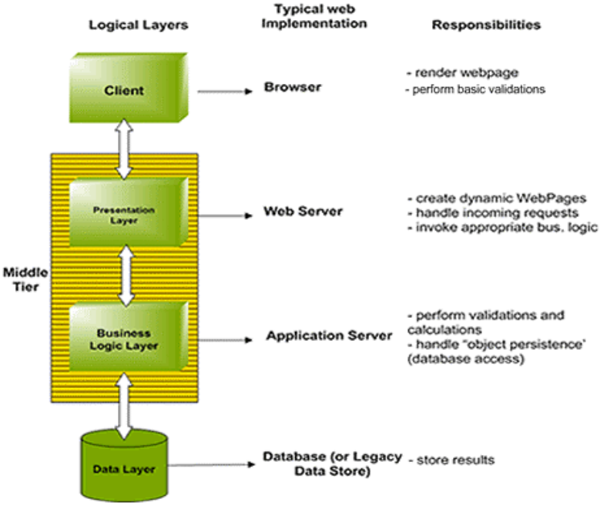

Figure 1 - Logical Layers of Application

Implementation View

Architecture Tiers
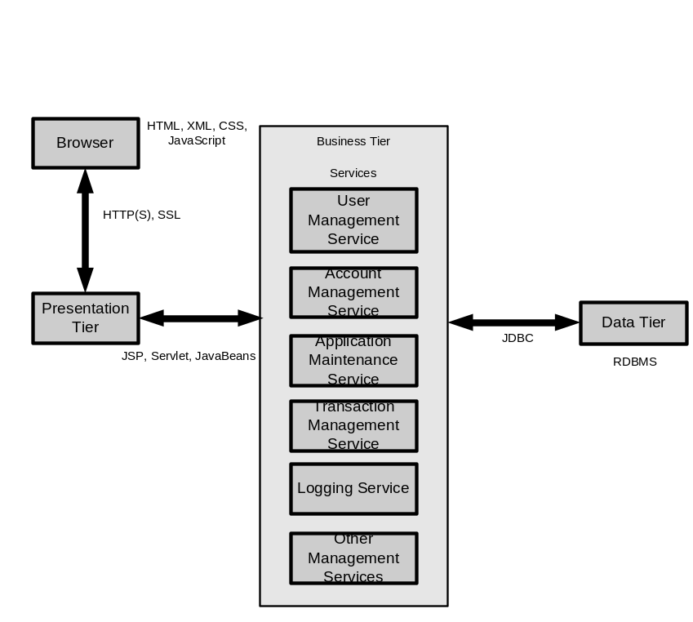
Figure 2 – Architecture Tiers

The application, as depicted in the Logical View section, will be three-tiered. It comprises of the Application Client tier, the Middle tier (Presentation and Business logic tier) and the Enterprise information tier (backend).

The Application Client Tier

The Application Client tier will be a browser-based thin client. The Client tier will present its user interface through a web browser in the form of HTML.

The Application Middle Tier

The middle tier comprises of two sub-tiers: the Presentation tier and the Business Logic tier.

Presentation Tier

The presentation tier components provide users with information-rich content as this tier hosts the JSP and Servlet. It presents dynamic contents to the users accessing the application using a web browser. The JSP technology in conjunction with Struts Tag Library will allow developers to create a higher level of reusable, maintainable, and dynamically generated web pages.

JavaScript (.js), Cascading Style Sheets (.css) files, and Custom Tag Libraries will be used to standardize and enhance the maintainability and interactivity of the presentation tier.

Business Logic Tier

The Business logic tier will host business-specific logic and system services such as the User Management Service, Account Management Service, Transaction Management Service, Data Access Service and a bunch of other services as well. Theses Services/Components hosted at the Business Logic tier will interact with the Enterprise Information System tier and other services to execute various requests.

The Enterprise Information System Tier

The Enterprise Information System (EIS) tier is comprised of an RDBMS server and other enterprise information servers. This tier will provide an information infrastructure for the application.

Application Client Tier Model

The Application Client tier consists of an HTML-based user interface. A client connects to the application using a web browser.

Technologies

- JavaScript
- Cascading Style Sheets (CSS)
- Secure Socket Layers (SSL)
- Hyper Text Transfer Protocol Secure sockets (HTTPS)
- Hypertext Mark-up Language (HTML)

Security considerations

- SSL is used to encrypt the confidential information transmitted over the network.
- An encrypted SSL connection will require all information sent between a client and a server to be encrypted by the sending software and decrypted by the receiving software, protecting private information from interception over the Internet. In addition, all data sent over an encrypted SSL connection will be protected with a mechanism for detecting tampering - that is, for automatically determining whether the data has been altered in transit. This means that users will confidently send private data to EAGLS, trusting that SSL keeps it private and confidential.

Browser compatibility and accessibility issues

EAGLS Web Application will support all major web browsers.

Since HTML is continuously changing and different browsers support different elements, one must ensure that pages are readable and accessible in all browsers, which are commonly used in Web Environment like Netscape or Internet Explorer. When a browser encounters tags it doesn't understand or can't display, degradation takes place. This degradation will cause some of your page content to be lost to the browser.

The HTML standards were written keeping browser compatibility issues in mind. New attributes to older tags are safely ignored so that the rest of the tag can still function normally, and new tags are written with alternative display for browsers that don't support them. There are many elements of HTML that can't be displayed or can be turned off in browsers such as images, java, and frames. Using the appropriate methods to provide an alternative message to those who can't see those elements or have turned them off is one way to design for graceful degradation.

EAGLS web interface will be designed with graceful degradation in mind, by utilizing the built in elements of the HTML standards, hence EAGLS pages will look gracefully consistent in major web browsers (Netscape and Internet Explorer) and are accessible.

Presentation Tier Model

In presentation tier, we adopt an MVC based framework, Struts, that is an initiative of the Apache Jakarta project (http://jakarta.apache.org/struts/index.html). The core of the Struts framework is a flexible control layer based on standard technologies like Java Servlets, JavaBeans, ResourceBundles, and Extensible Markup Language (XML).

Struts encourages application architectures based on the Model 2 approach, a variation of the classic Model-View-Controller (MVC) design paradigm.

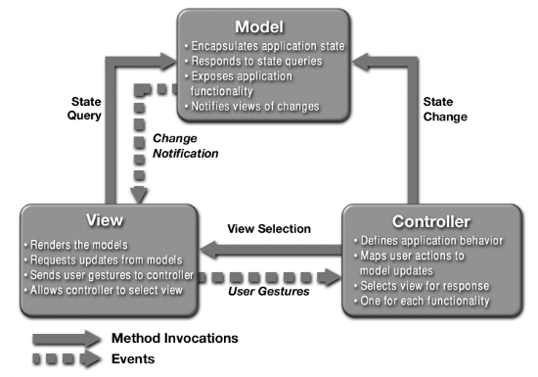

Figure 3 - Model-View-Controller

In Model 1 web application, a collection of JSP pages work largely independently of each other. Each page directly transfers control to the next page. There is no separate controller. The main problems with model 1 are: a simple change can result in a cascade of changes in many different pages with unpredictable consequences, and complexity grows fast as well, and what might originally look simple and straightforward can quickly turn into a big mess as you add more pieces.

Model 2 represents a framework based on the Model-View-Controller (MVC) system. Each page reports back to the controller, which decides what to do next. Struts provides its own Controller component and integrates with other technologies to provide the Model and the View. For the Model, Struts can interact with any standard data access technology, including Enterprise Java Beans, JDBC, and Object Relational Bridge. For the View, Struts works well with JavaServer Pages, Velocity Templates, XSLT, and other presentation systems.

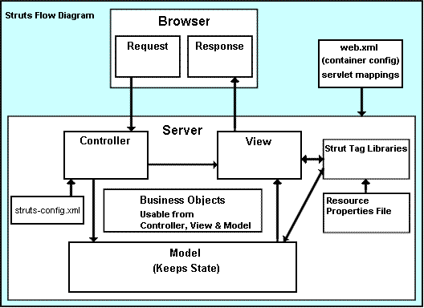

Figure 4 - Struts Flow Diagram

The Struts framework provides the invisible underpinnings every professional web application needs to survive. Struts helps developers create an extensible development environment for application, based on published standards and proven design patterns.

The Model-View-Controller Design Pattern

In the MVC design pattern, a central Controller mediates application flow. The Controller delegates HTTP requests to an appropriate handler. The handlers are tied to a Model, and each handler acts as an adapter between the request and the Model. The Model represents, or encapsulates, an application's business logic or state. Control is usually then forwarded back through the Controller to the appropriate View. The forwarding can be determined by consulting a set of mappings, usually loaded from a database or configuration file. This provides a loose coupling between the View and Model, which can make an application significantly easier to create and maintain.

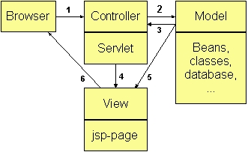
Figure 5 - The Model-View-Controller Design Pattern

Struts Framework Overview

True to the Model-View-Controller design pattern, Struts applications have three major components: a servlet controller, which is provided by Struts itself, JSP pages (the "view"), and the application's business logic (or the "model").

.
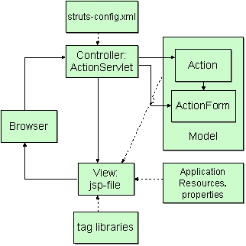
Figure 6 - Struts Framework Overview

The Struts controller servlet bundles and routes HTTP requests to other objects in the framework, including JavaServer Pages and org.apache.struts.action.Action subclasses provided by the Struts developer. When initialized, the controller parses a configuration resource file. The configuration resource defines (among other things) the org.apache.struts.action.ActionMappings for an application. The controller uses these mappings to turn HTTP requests into application actions. An ActionMapping will specify:

- a request path (or "URI"),
- the object type (Action subclass) to act upon the request,
- and other properties as needed.

The Action object can handle the request and respond to the client (Web browser), or indicate that control should be forwarded elsewhere. For example, if a login succeeds, a login action will forward the request onto the mainMenu.

Action objects have access to the application's controller servlet, and so have access to that servlet's methods. When forwarding control, an Action object can indirectly forward one or more shared objects, including JavaBeans, by placing them in one of the standard collections shared by Java servlets.

In a Struts application, most of the business logic will be represented using JavaBeans. An Action will call the properties of a JavaBean without knowing how it actually works. This encapsulates the business logic, so that the Action can focus on error handling and where to forward control.

JavaBeans can also be used to manage input forms. With Struts, a set of form bean classes will be defined by subclassing org.apache.struts.action.ActionForm, and the data for an input form will be easily stored in these form beans. The bean is saved in one of the standard, shared context collections, so that other objects, especially an Action object, can use it.

The form bean will be used by a JSP to collect data from the user, by an Action object to validate the user-entered data and then by the JSP again to re-populate the form fields. In the case of validation errors, Struts has a shared mechanism for raising and displaying error messages.

A Struts form bean is declared in the configuration resource, defined in a Java source file, and linked to an ActionMapping using a common property name. When a request calls for an Action that uses a form bean, the controller servlet either retrieves or creates the form bean, and passes it to the Action object. The Action object can then check the contents of the form bean before its input form is displayed, and also queue messages to be handled by the form. When ready, the Action object will return control with a forwarding to its input form, a JSP. The controller will then respond to the HTTP request and direct the client to the JavaServer Page.

The Struts framework includes custom tags that can automatically populate fields from a form bean. The only thing most JavaServer Pages need to know about the rest of the framework is the proper field names and where to submit the form. Components like the messages queued by the Action can be output using a single custom tag.

The custom tags in the Struts framework are designed to use the internationalization features built into the Java platform. All the field labels and messages can be retrieved from a message resource, and Java can automatically provide the correct resource for a client's country and language. To provide messages for another language, simply add another resource file.

Internationalism aside, other benefits to this approach are consistent labelling between forms, and the ability to review all labels and messages from a central location. An Action object will either handle the business logic associated with a request, or in most cases, it will invoke another object, a JavaBean, to perform the actual business logic. This lets the Action focus on error handling and control flow, rather than business logic. To allow reuse on other platforms, business-logic JavaBeans will not refer to any Web application objects. The Action object will translate needed details from the HTTP request and pass those along to the business-logic beans as regular Java variables.

Neither the Action nor the JSP need to know (or care) from where the result comes. They just need to know how to package and display it.

Technologies

- JSP (Java Server Pages)
- JavaServlet
- Struts

Security considerations

The application will have the following security features:

- Both client side and server side validations will be used for error checking.
- Only valid requests will be forwarded to the Business tier.
- Session will be verified.
- Only authenticated users will be allowed access to the Business tier.
- A user session expiration policy will be implemented.

Error handling

- Validation errors will be reported to the user on the user interface.
- In addition to the client side user input validation, proper server side validation will be performed. This is to ensure a consistent behaviour in circumstances where user might have disabled JavaScript support using the browser settings.

Business Tier Model

Business Logic Tier Components

This section describes the implementation of the Business Tier. The Business tier consists of the Services and DAOs. An overview of the Business Logic Tier is shown below

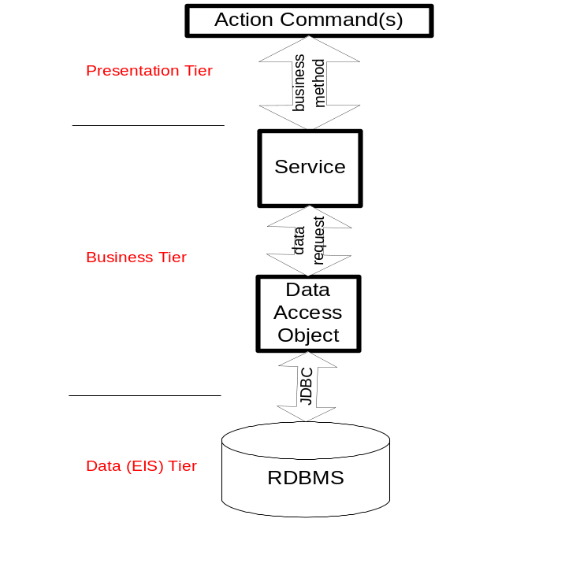
Figure 8 - Business Tier

Service

A Service is a component, which encapsulates business logic in it. Each Service consists of methods that can interact with one or more DAO to get/save data from/to the database. The essence of Software Architecture based system architecture is further explained in a later section.

Data Access Object (DAO)

The primary task of DAO is to provide persistence mechanism to the business model. Its responsibilities include:

- Obtain and maintain (open and close) connection from the connection pool
- Perform model (state) validations
- Separate a data resource’s client interface from its data access mechanism
- Adapt a specific data resource’s access API to a generic client interface

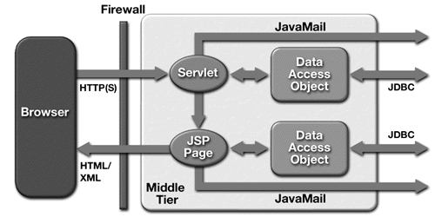

Technologies

- J2SE
- JDBC
- Torque (http://db.apache.org/torque/)
- Extensible Mark-up Language (XML)

Connection Pooling
One of the most expensive database operations is establishing an initial connection. Depending upon the database that is being used, a connection has to perform protocol handshaking, verify user information, open disk files, create memory caches, etc. In a typical application, the end user pays the performance price for this connection
While we can't get rid of the time a connection takes, EAGLS will establish a collection (or pool) of connections ahead of time that are ready and waiting for someone to use. By establishing these connections in a separate thread, EAGLS will not have to pay any (or at least only pay minimal) performance penalties. EAGLS will just have to "borrow" a connection from the pool, use it, and then return it when complete.
Benefits:
Scalability By improving the overall performance, EAGLS will allow the entire application to scale much better.
Code reuse/reduction Using a connection pool EAGLS can decrease the amount of code that has been written and maintained, and it allow reusing code that has already been tested and proven to work.
Central administration Connection parameters (user name, password, custom arguments, etc.) can be changed in a central location without having to change (or even recompile) your application.
Security Because EAGLS needs only a data source name when using a connection; there is no danger of inadvertently giving out user names and passwords for database.
Performance This benefit is worth reiterating because it is one of the largest (and most noticeable) improvements that EAGLS can make when it needs to use a database.

Security considerations

- Only the presentation layer will be allowed access to the business layer. The business layer will be protected from all other types of access.
- The application will ensure that proper role validation is performed before executing a method.

Validation and Error handling

In case of an error:

- The application will log the error.
- Provide a user-friendly message on the user interface.
- Provide instruction on how to continue using the system.

Performance and Scalability

As the number of EAGLS application users continues to grow there will be a need to scale the system. The system will be designed to allow easy horizontal and vertical scaling.

Data Persistence and EIS Tier Model

The Data Persistence tier consists of the RDBMS server and other data stores. The RDBMS server will be accessed using the JDBC APIs.

Technologies

- JDBC

Data Access mechanism

Mechanism | Method
Data access mechanism | JDBC
Connection pooling | Vendor specific
Connection acquisition | JNDI Data Source (in conjunction with Connection pooling)
SQL execution | PreparedStatement object and stored procedure

Security considerations

- Ensure user credentials for the database are not saved in a format that will compromise security of the database.
- Ensure that all text in the generated SQL is properly quoted to prevent any possible malformed queries.
- Ensure that database access roles are implemented.
- Ensure user read-only access to the database where applicable.
- Ensure database integrity constraints will be implemented for consistency and integrity of the data.
- Ensure scheduled backups of the application data.

Validation and Error handling

A logging mechanism will be implemented to log all the database access errors for audit purpose.

Components

Client side components

Component | Description
JavaScript | For client-side data input validation
CSS | Used to render consistent user interface
HTML | UI (which is displayed/rendered on client’s browser)

Server side components

Component | Description
Java Server Page | Dynamically generates HTML
Struts | An open source MVC based framework
Service | Encapsulates business logic
Data Access Object | Provides persistence mechanism

Exception Handling

Location | Type | Responsible | Mechanism
HMTL forms | Simple criteria | JavaScript | JavaScript
HMTL forms | Complex criteria | Web tier | Struts based input form validation
Web tier | Web application error | Web tier | Takes user to an error screen showing message (cause of error and how to resolve it) and provide a mechanism to continue the current operation.
Database | Critical database error | DAO | Provides a user-friendly error message and uses the web tier to handle the exception.

Deployment View

Deployment Diagram
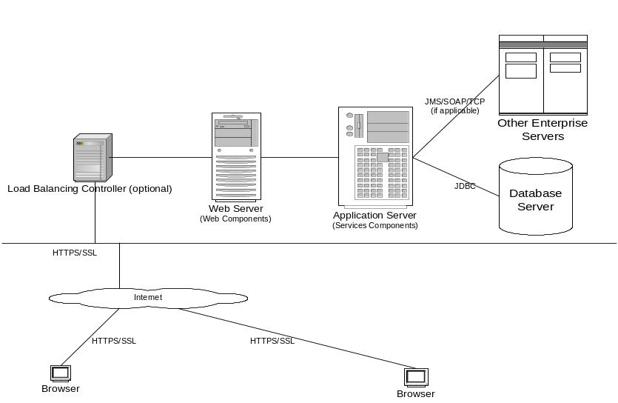
Figure 10 – Deployment View of the Application

The above diagram illustrates the high-level deployment architecture of EAGLS Web Application.

Software Architecture

This architecture defines an application model of a service-oriented system, which encapsulates business logic into service components. As a server-side infrastructure, this system provides a framework to define, implement, and deploy service components or applications. Services can be properly used as a group or as independent pieces of executable software.

Essence of the Service Architecture

- A service is a component or an application process, which encapsulate specific business logic and functions.
- A service can also utilize the services of other services.
- A service is accessible through an interface.
- Additional services can be added and configured into this system.

Service Diagram

The Service Diagram is depicted below.

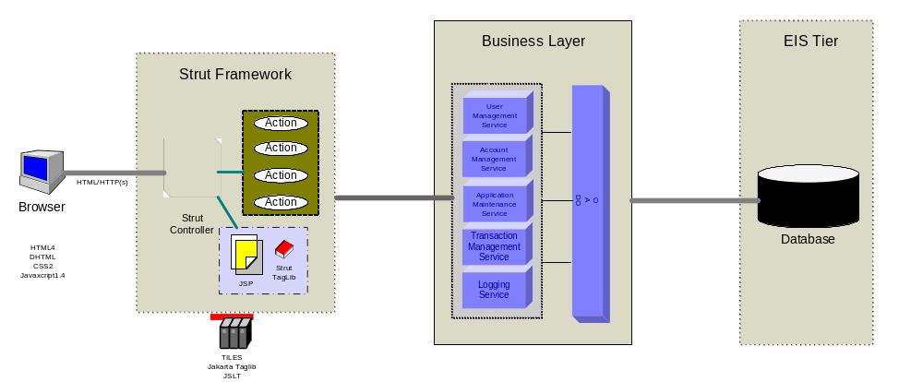
Figure 11 – Application Services

Service Description

User Management Service

The User Management Service will control user’s privileges to access certain resources.

The User Management Service will be used to create profiles for Non-Authenticated users, modify profiles and assign user rights to the existing users, etc.

User management will also include:
- Management of user profiles
- Management of user rights
- Management of user favourites

Account Management Service

The Account Management Service will be used for viewing and maintaining accounts.

Its major responsibilities include:
- Management of Individual as well as Central accounts.
- Management of a particular account information
- Management of account transferring
- Management of authorization controls

Application Maintenance Service

The Application Maintenance Service will be used to perform daily tasks like processing account holder’s requests for credit limit changes etc.

Its major responsibilities include:
- Management of account credit limits
- Management of requests for replacement card
- Management of Convenience Check orders
- Management of Traveler’s Check orders

Transaction Management Service

The Transaction Management Service will be used to manage different transactions for individually billed accounts and centrally billed accounts both.

Its major responsibilities include:
- Management of Transaction details
- Management of Tax details
- Management of requests for Sales Draft

Logging Service

The Logging Service will be used to log all the activities of the EAGLS Web Application. It will provide logging services to other components.

There will be five types/levels of logging during development to allow the developers to track and debug system problems. During production, the system will only log messages that the administrator specified in configuration file. The various logging levels are

- Info
- Debug
- Warning
- Error
- Fatal

Apache’s Log4J will be used in EAGLS Web Application for logging purposes.

Other Security Services

EAGLE security services will be designed to ensure that only users authorized to use them access those resources. Access control will involve two steps:

Authentication:

An entity (User or Another system like TSYS etc.) must establish its identity through authentication. It will do so by providing authentication data (user name and password). An entity that can be authenticated is called a principal. A principal can be a user or another program.

Authorization:

When an authenticated principal tries to access a resource, the system determines whether the principal is authorized to do so based on the security policies in force in the application's security policy domain.

Containers provide two security methodologies: declarative and programmatic. EAGLS will use programmatic security methodology. Programmatic security refers to security mechanisms accessed within a program. An application component provider accesses programmatic security for Web components with J2EE platform security APIs.

Architecture Patterns

Architectural patterns are used to solve recurring architecture problems. An architectural framework or infrastructure is a set of components on which we can build a certain kind of architecture.

Singleton

It ensures common object for all in process requests.

Data Access Objects

Data Access Objects provide access to the particular data resource without coupling the resource’s API to the business logic. DAO objects are best suited to hide the complexity of the data store dependent APIs where more than one type of data-store is used (e.g. RDBMS server).

Model-View-Controller

The classic Model, View, Controller (MVC) design pattern is selected as the architecture pattern. The Model holds the data displayed by the View and is managed by the Controller. The View is responsible for delivering output to the user, and the Controller reacts to user actions and updates the Model appropriately. Separating user display (View) from actions (Controller) promotes code reuse. Separating the data (Model) from the actions performed on it (Controller) allows the design of a system to be independent of its backend data storage. If designed correctly, a system based on the MVC design pattern does not know whether the data provided to the Model component is stored in a DB2, Oracle database or a set of XML files.

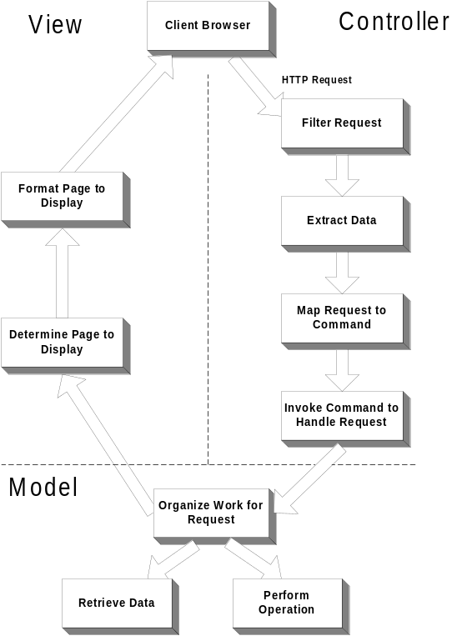
Figure 12 - Model-View-Controller

Software Design

The following section discusses the application design spanning across different tiers. In order to keep the discussion short and concise, the section specifically discusses the classes/objects that take part in the log in action of a user. Others follow the same design pattern.

High Level Package Hierarchy

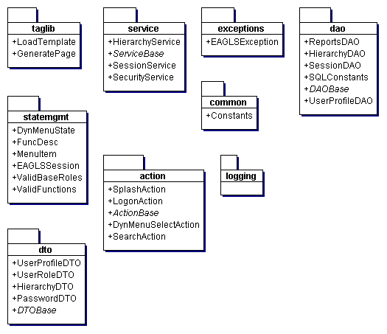

Major Components

DAO

Every data access component in EAGLS is based upon the DAO pattern. A Data Access Object class can provide access to a particular data resource without coupling the resource's API to the business logic.

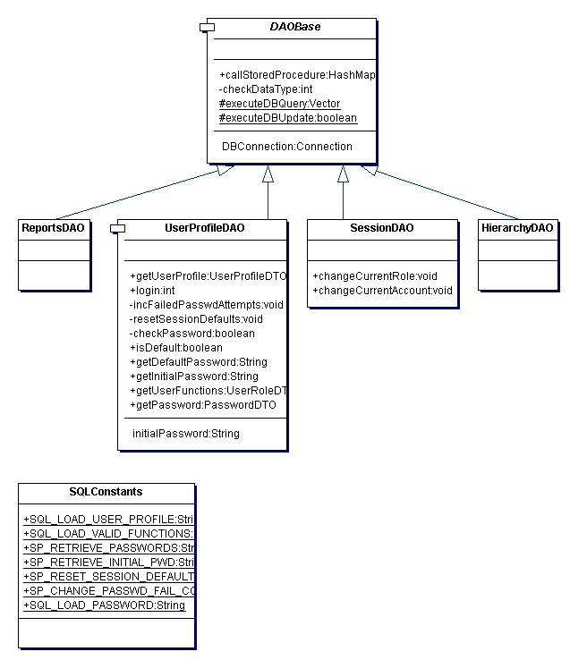

The following sequence diagram illustrates the sequences of operations that take place when the method login() of UserProfileDAO is called by an object.

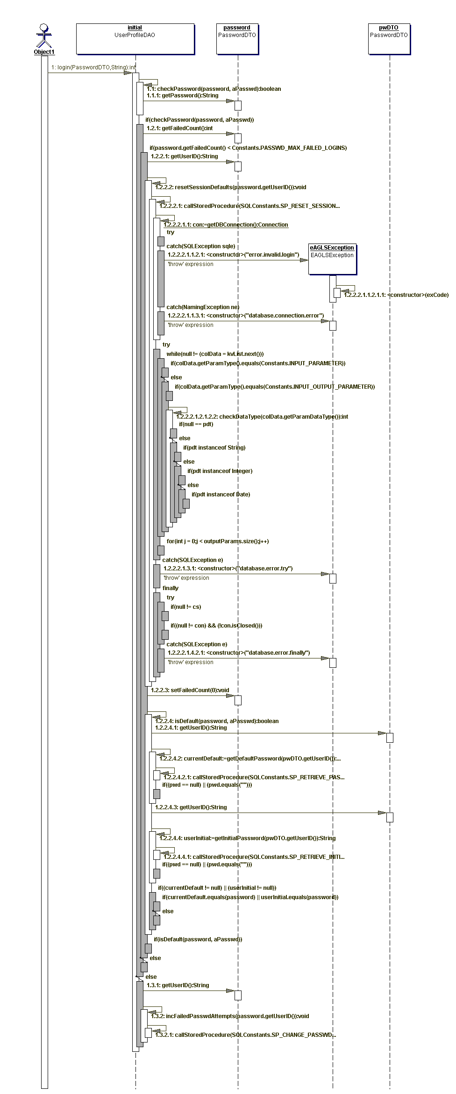

Services

The purpose of different Services is to actually provide the business intelligence to the application. Acting as an agent for action objects, they are responsible for carrying out the required business logic on behalf of the client.

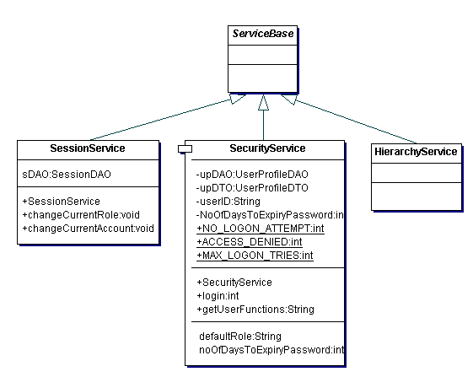
The action objects populate the page bean and call the appropriate method of the service. The service in turn uses one or more DAOs to carry out a complete business process.

Action Object (AO)

In EAGLS Web Application, the AOs will act as controllers that recognize the user gestures and based upon the request parameters, call the appropriate service methods.

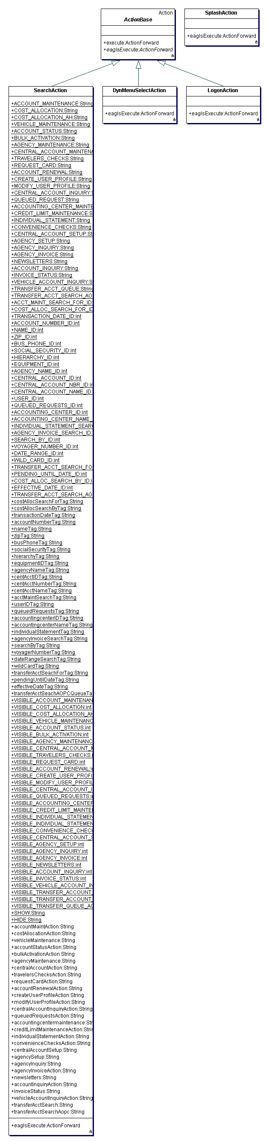

The following diagram illustrates the sequence of operations that take place when the controller layer recognizes the user gesture of logging into the EAGLS Web Application. Note the role of the Service and DAOs also.

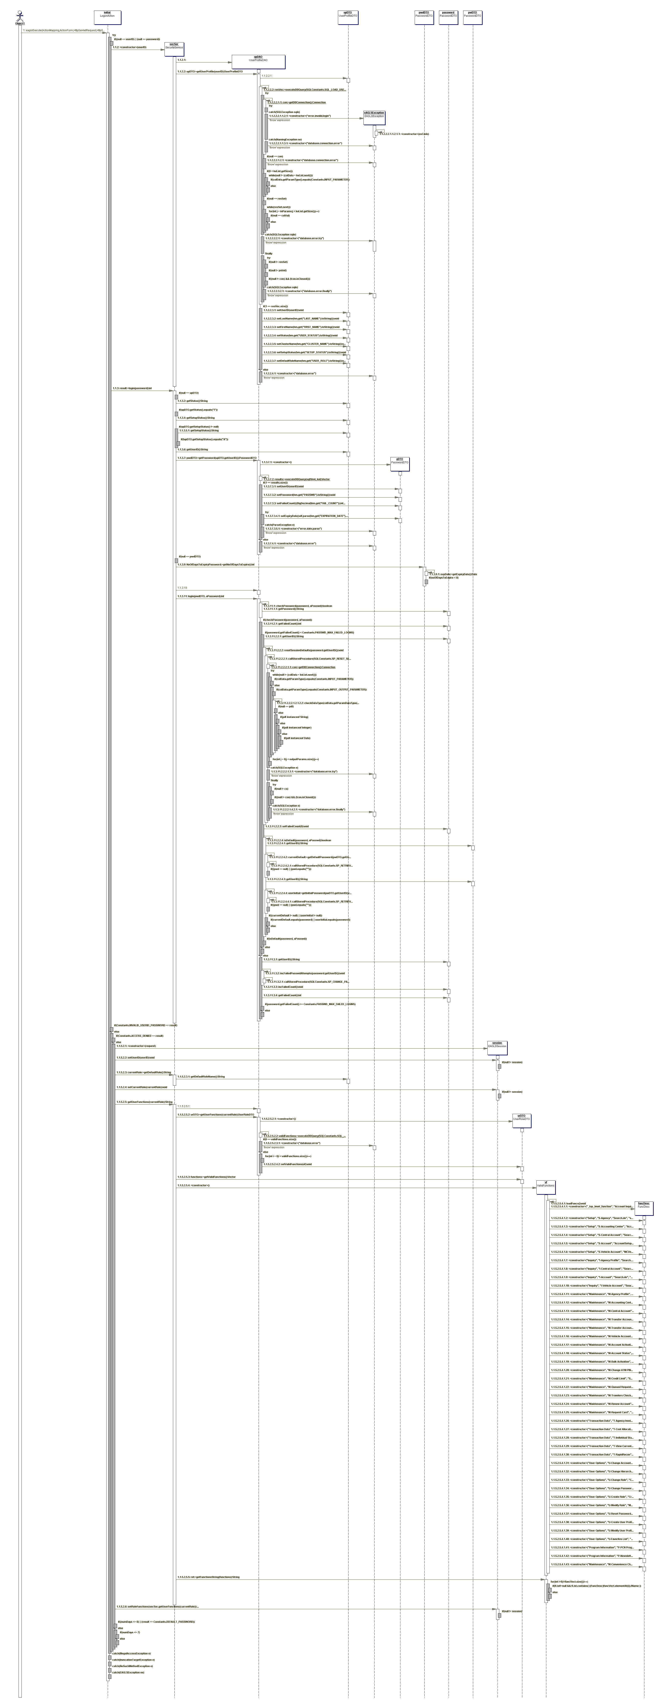

Generic Components/Utility Classes

Utility classes are actually some of the generic components that contain utility methods used by all components in all layers. Besides offering a common usage protocol to all the tiers, they serve as a re-usable and extensible code library.

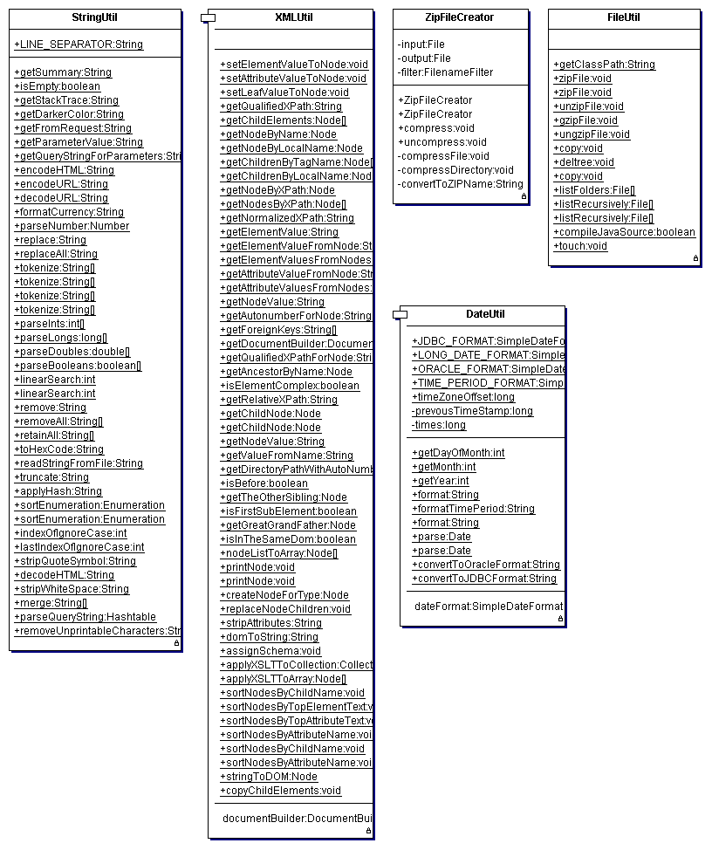

Security Design

This section will discuss the security design of the EAGLS Web Application. This includes not only the security and authentication schemes involved but will also address various security threats for a web application.

Authentication

The authentication will mainly take place in the presentation layer. The users will be authenticated from a login screen by entering their username and password. The credentials will first be checked at the client tier for basic format errors (e.g. empty usernames) and then will be passed to the web/application server via a SSL connection. The relevant service will first see that the user is a valid user by searching for the user profile in the database.

In case the user is not a valid user or active, the application will not try to authenticate and will immediately display an error message to the user.

If a user attempts to log in while he/she is already logged in, his previous session will be invalidated before continuing with the login process.

Authorization

Presentation Tier Authorization

In the Presentation Tier, it is necessary to determine these things:
- Which top level menu items should be displayed for a user
- Which side-level menu items should be displayed for a given top-level menu
- Which help topics should be displayed for a user, given their rights
- Which buttons (or links) should be displayed for a given screen
- What content should be displayed on the start pages.
- Which pages/resources should be accessible to a user

All this information will be predetermined and will be stored in the user’s session. It will be necessary for all pages and resources to be aware of their security constraints and be able to deny access to unauthorized users.
All the information that is not available to a user will not be shown to him/her. The user will never get an access denied message unless he tries to disrupt the normal flow and access the application in an abnormal manner.
It will be necessary that cookies be enabled. Otherwise the session tracking mechanism will not work. The user will be shown a warning message whenever cookies are disabled.

Business Tier Authorization

In the Business Tier it will be necessary to determine which methods of a business service are accessible to a particular type of user. Since this type of restriction is dynamic, it will not be hard-coded into the services. Instead it will be the responsibility of the particular Actions to determine whether the user can invoke a service method or not. The Action will check the user role and decide the appropriate workflow for each type of role. Under no circumstance should the business tier classes interact with the user’s session classes because that would create an unnecessary coupling.

Database Tier Authorization

Each user of EAGLS can have one or multiple roles. A Role decides the EAGLS system access level and system behaviour for that user. It defines functional access (screens) and data access. A user will always be associated with his default role unless he changes to another role in his role list. Once changed, a user will be associated with his/her current role, which may or may not be the default role.

EAGLS External Interfaces

EAGLS also exposes its interfaces to the outer world in the form of Messages to the Message Queue. Messages can be posted and received asynchronously.

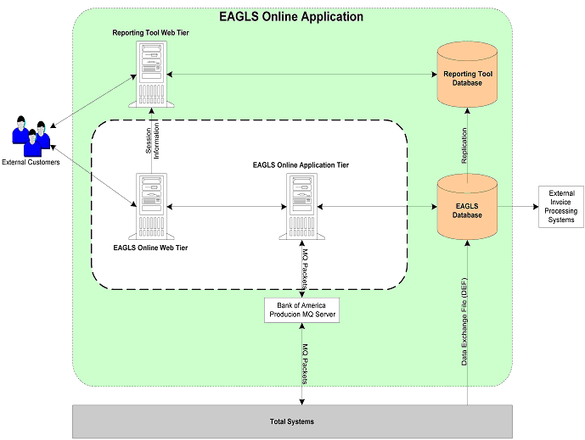

A typical transaction between TSys and EAGLS has been depicted below.

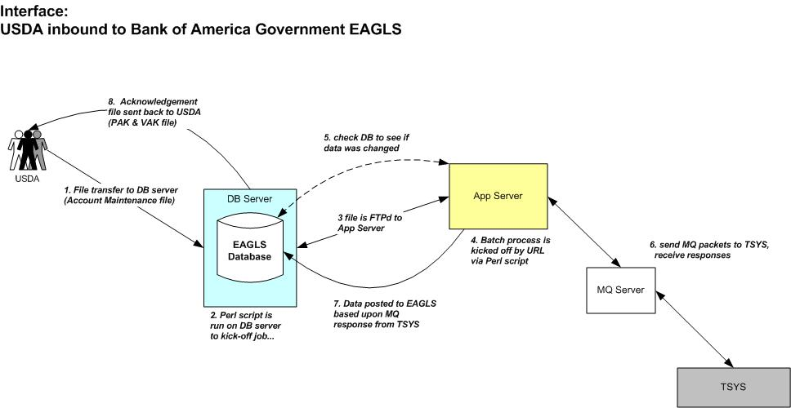

The new EAGLS system will extend the currently followed application architecture to a full J2EE compliant architecture, keeping all the interfaces to the external systems intact.

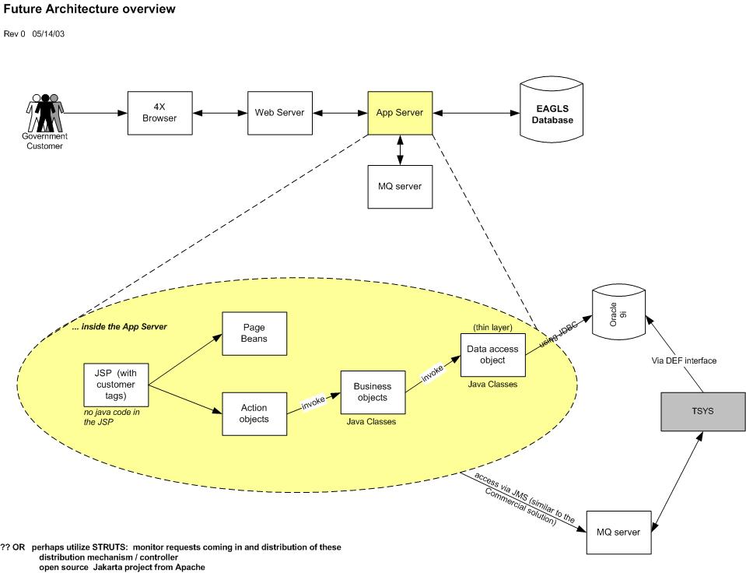

Summary

The Software Architecture has been designed to produce a highly flexible, scalable, and reusable application. As new components are developed and operating procedures change or evolve, this system can be reassembled, changed and extended.

The recommended Application Architecture for the EAGLS Web Application will use the J2EE architecture and industry-standard software components to accomplish the task of developing software that fulfills the requirements associated with the project.

Reference

- Code Conventions for the Java Programming Language, Sun Microsystems, http://java.sun.com/docs/codeconv/html/CodeConvTOC.doc.html
- Data Access Object, Sun Microsystems, http://java.sun.com/blueprints/patterns/DAO.html
- Java Servlet Specification, Sun Microsystems, http://java.sun.com/products/servlet/index.html
- Apache Jakarta Struts User Guide, http://jakarta.apache.org/struts/userGuide
- Apache Jakarta Struts Overview, http://www.jspinsider.com/tutorials/jsp/struts/strutsintro.view
- Solve your servlet-based presentation problems, JavaWorld, http://www.javaworld.com/javaworld/jw-11-2000/jw-1103-presentation_p.html
- Ted Husted's Struts MVC resources page, http://www.husted.com/struts/links.htm#mvc
- Model View Controller model 2 in Struts documentation, http://jakarta.apache.org/struts/userGuide/introduction.html#mvc
- Introduction of MVC by sun, http://java.sun.com/blueprints/patterns/j2ee_patterns/model_view_controller/index.html
- Presentation of Struts, MVC 2 with a detailed example, http://www-106.ibm.com/developerworks/library/j-struts/
- Presentation of Struts, with J2EE patterns, http://www.sys-con.com/java/article.cfm?id=1175

